GHG Database and Dashboard Report
Step 3: Creating the GHG Database Due to connection issues with the SQL server through VPN, I created the GHG database in DBeaver. Per the instructions, when I first encountered connection issues, I attempted multiple troubleshooting steps:
- Restarted ALL available MSSQLSERVER3 services.
- Verified that the database created was on SQL Server Express Edition (SQLEXPRESS), but it was not listed in Windows Services.
- Ensured that AWS RDS was Publicly Accessible by checking the AWS Console → RDS settings, confirming "Publicly Accessible: Yes."
- Adjusted Security Group Settings:
  - Inbound Rule: Opened MS SQL (TCP 1433) to 0.0.0.0/0 (temporarily allowing all IPs).
  - Outbound Rule: Allowed all traffic.
- Restarted the RDS Instance after modifying security settings.
- Tested connection using PowerShell and eventually created a new database on a different VPN machine.

AWS Console Screenshot:
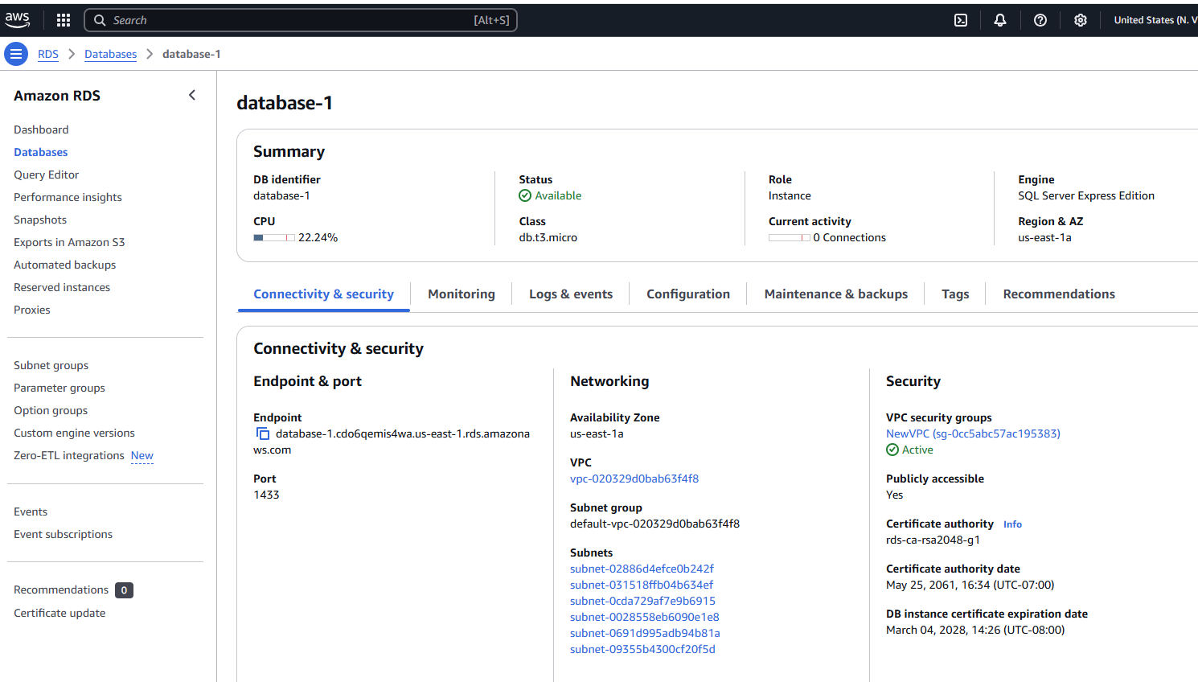
Once the database was structured, I proceeded with Module 9: Cloud Computing and successfully deployed the database on AWS RDS. When the AWS console indicated that my database was "Available," I accessed it and refreshed my browser to ensure updates were reflected.
DBeaver screenshot:
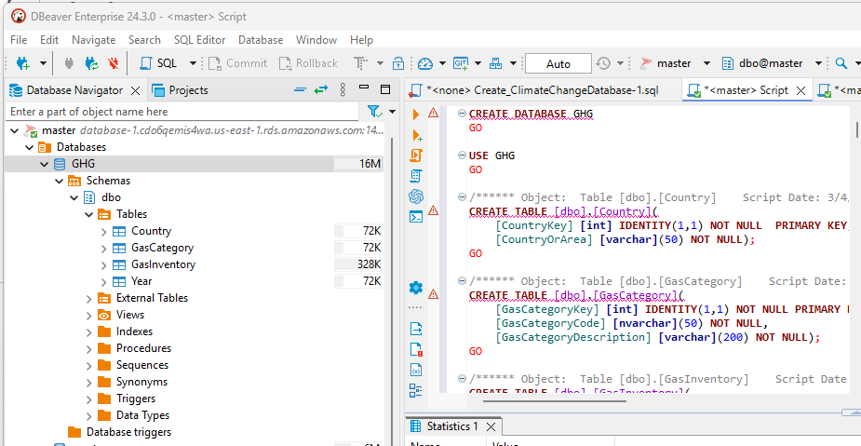

Since Tableau Public does not allow direct server connections, I had to extract data via CSV files. This process created four separate files, requiring additional steps to merge them properly. After facing challenges in Tableau with data integration, I used SQL scripts to join the datasets efficiently. The merged dataset provided better structure and improved the accuracy of my Tableau dashboard.

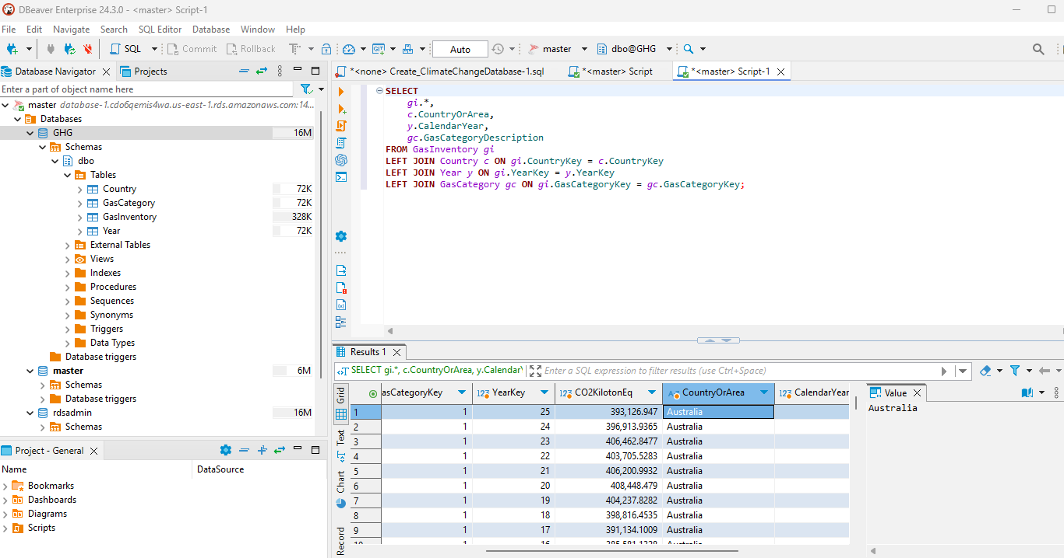
Tableau Dashboard Screenshot:
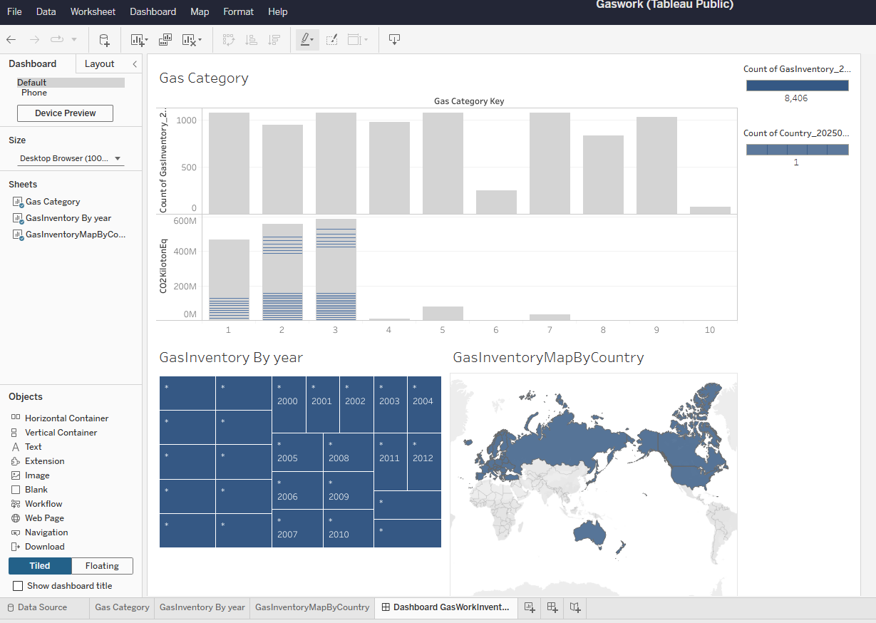

Dashboard Objectives and Analysis
Questions the Dashboard Aims to Answer:
- What are the trends in GHG emissions over time?
- Which countries contribute the most to GHG emissions?
- How do different gas categories compare in terms of emissions?
- Are there any seasonal or regional patterns in GHG emissions?
By answering these questions, the dashboard helps in identifying major contributors to emissions and analyzing trends that can inform policy decisions and sustainability efforts.
Challenges with Tableau: Due to the fact that I wasn’t able to connect to the extended version of Tableau through the VPN server for this assignment, I had to use the limited edition of Tableau. This significantly restricted my options in several ways, including:
- The ability to work with only one dataset at a time, preventing multi-source integration.
- Limited advanced analytics features, such as forecasting and AI-driven insights.
- Constraints in data blending and joining capabilities, making it difficult to combine multiple data sources for deeper analysis.
- Fewer custom visualization options, reducing the ability to enhance clarity and storytelling through advanced charting techniques.
These limitations impacted the overall depth of the dashboard, requiring a more simplified approach to data visualization.

Why I Chose This Dashboard Format:
- Gas Category Bar Chart: Helps compare different gas emissions visually, making it easy to see which category contributes the most.
- Gas Inventory By Year (Treemap/Heatmap): Effectively shows distribution over time, allowing for easy trend identification.
- Geographic Map (Gas Inventory By Country): Provides a global perspective on emissions, highlighting the highest-emitting regions in an intuitive format.
The chosen visualizations enhance clarity and support data-driven decision-making by making complex data more accessible.

I created second dashboard from the file I was able to merge

1. Gas Category Analysis
- Which gas category contributes the most to GHG emissions?
- How do different gas categories compare in terms of total CO2 emissions?
- What trends can be observed in gas emissions over time?

2. Yearly Gas Emission Impact
- Are there significant fluctuations in emissions over the years?
- Do certain years show a peak in emissions, and what factors could contribute to this?
- How do different gas categories contribute to overall emissions each year?
- Are there patterns in gas emissions across multiple years?

3. Geographical Analysis (Map)
- Which countries or regions have the highest GHG emissions?
- Are there geographical patterns in emissions that correlate with industrial activity or policy changes?
- Do certain countries exhibit a significant increase or decrease in emissions over time?
- How does emissions data vary by location in relation to gas category distribution?
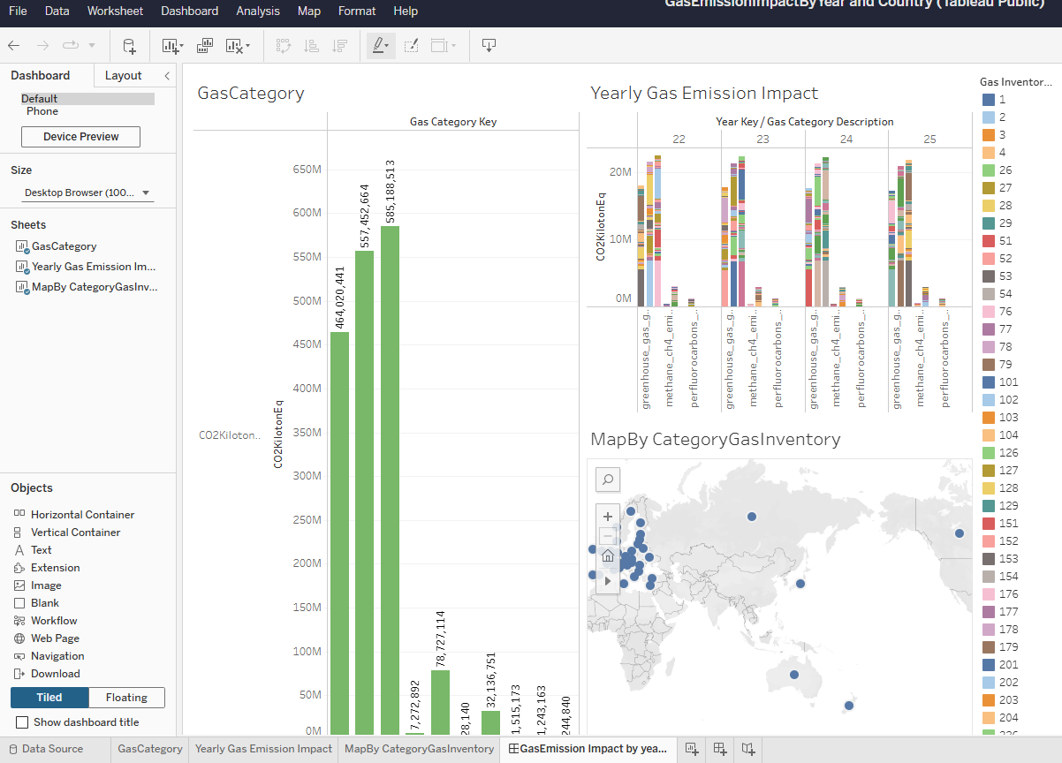
Dashboard File: https://public.tableau.com/authoring/Gaswork/Sheet1/Dashboard%20GasWorkInventory#1
Updated Tableau from merged data
https://public.tableau.com/authoring/GasEmissionImpactByYearandCountry/GasEmissionImpactbyyearandcountry#1

